1.Debugging String Matching Code (Pattern Longer Than Text Not Handled in C)
The following brute force string matching implementation in C assumes that the pattern length is
less than or equal to the text length, but it does not explicitly handle the case where the pattern is
longer. Carefully analyze why this edge case must be checked before beginning the search. Apply
systematic debugging so that the function safely exits or reports no match when the pattern cannot
fit within the text. Optimize the corrected implementation for robust control flow and clear
readability. Analyze the time complexity of the corrected version and rewrite the final C code with
proper comments.
#include &lt;stdio.h&gt;
#include &lt;string.h&gt;
void stringMatch(char text[], char pattern[]) {
int n = strlen(text), m = strlen(pattern);
int i, j;
for (i = 0; i &lt;= n - m; i++) {
for (j = 0; j &lt; m; j++) {
if (text[i + j] != pattern[j])
break;
}
if (j == m)
printf(&quot;Match at %d\n&quot;, i);
}
}

ANS:
#include <stdio.h>
#include <string.h>

void stringMatch(char text[], char pattern[]) {
int n = strlen(text);
int m = strlen(pattern);
int i, j;

for (i = 0; i <= n - m; i++) {
for (j = 0; j < m; j++) {
if (text[i + j] != pattern[j])
break;
}

if (j == m)
printf("Match at %d\n", i);
}
}

int main() {
char text[100], pattern[50];

printf("Enter text: ");
gets(text);

printf("Enter pattern: ");
gets(pattern);

stringMatch(text, pattern);

return 0;
}
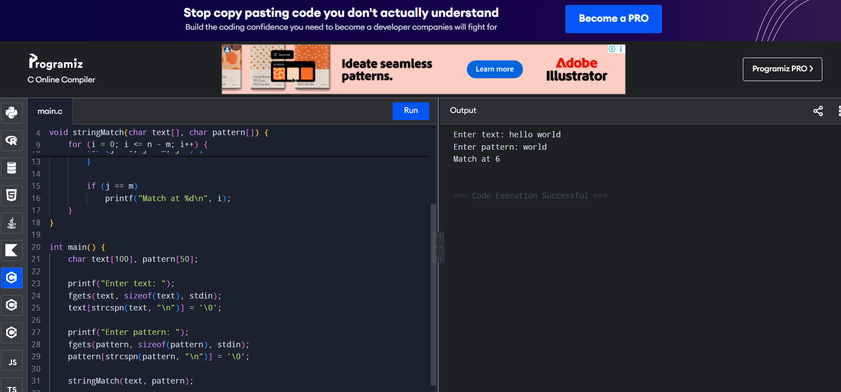

2.Debugging Closest Pair Code (Distance Formula Uses Addition Instead of Difference)
The following brute force Closest Pair implementation uses an incorrect distance formula by
adding coordinates instead of taking their differences, which produces meaningless geometric
distances. Carefully analyze the mathematical expression and explain why the computed minimum
is invalid. Apply systematic debugging to restore the correct Euclidean distance formula for all
point pairs. Optimize the implementation by storing coordinates in temporary variables for clarity.
Analyze the time complexity of the corrected solution and rewrite the final code with proper
comments.
import math
def closest_pair(points):
min_dist = float(&#39;inf&#39;)
for i in range(len(points)):
for j in range(i+1, len(points)):
dist = math.sqrt((points[i][0] + points[j][0])**2 +
(points[i][1] + points[j][1])**2) # ERROR
if dist &lt; min_dist:
min_dist = dist
return min_dist

ANS:
import math

def closest_pair(points):
min_dist = float('inf')

for i in range(len(points)):
for j in range(i + 1, len(points)):
dist = math.sqrt(
(points[i][0] - points[j][0])**2 +
(points[i][1] - points[j][1])**2
)

if dist < min_dist:
min_dist = dist

return min_dist

points = [(0, 0), (3, 4), (1, 1), (5, 2)]

print("Minimum distance:", closest_pair(points))

